Minutes of the Library Trustees Meeting
Bushnell-Sage Library
January 12, 2024

Present: Pat Levine, Anne Beattie, Barbara Reeves, Trustees
Deena Caswell, Library Director
Stefanie D’Angelo, Bushnell-Sage Children’s Coordinator
Sig Spiegel, President of Friends of the Library

The meeting was called to order at 4:00 p.m.

The Minutes of Oct. 5, 2023, and December 7, 2023, were approved by Pat Levine and Anne Beattie. Barbara Reeves abstained.

DIRECTOR’S REPORT HIGHLIGHTS: (see attached)
D. Caswell reviewed her monthly report. Staff Member Eastlynd Bates has left for a full time position elsewhere. A motion was made and approved to send her a thank you note for her four years of service. Full and part time staff are encouraged to partake in professional development opportunities. Susan Butler inquired about art classes for children. Stefanie D’Angelo will reach out to her to discuss. Data shows that circulation and program attendance have continued to increase at a stunning rate. The biggest jump has been in children’s programming. There will be no rentals of the library spaces by outside groups according town policy.

BUILDING AND GROUNDS:
The gutters were cleaned by Four One Tree. An arborist will check the small trees in front of the library for needed pruning. The Board discussed looking into the use of security cameras.

CHILDREN’S PROGRAM COORDINATOR:
Deena Caswell spoke of the need to re-title the job, as the position’s responsibilities have grown. She presented the current job description, titled “Children’s Program Coordinator” juxtaposed with a new title “Youth Services Librarian” and its expanded duties. She envisions a deeper relationship between the library, older teens, and the Mt. Everett school library. The Board members decided to spend time thinking about the new job description and report back at the next meeting.

FY25 BUDGET:
Deena Caswell has discussed the future budget with Rhonda LaBombard and made a draft. The Library has to meet the Massachusetts Board of Library Commissioners’ guidelines for hours open and materials that will be purchased to qualify for State aid. Deena reviewed the amounts of separate budget line-items.

PROGRAM UPDATES:
The Maid is the current book club offering. Turn It Up author Tom Werman will visit on 2/3/24. A September writing workshop is being planned. A movie will be shown on the third Thursday of every month. Deena is exploring a Dungeons and Dragons program.

TRUSTEE ITEMS:
Deena reviewed for the Board the procedure for responding to book challenges. The policy is stated on the Bushnell-Sage website.

FRIENDS of the LIBRARY:
Sig Spiegel stated that donations continue to be made to the Friends.

NEXT MEETING:
The next meeting was set for Thursday, 2/8/24, at 3:00 p.m.

A motion was made and seconded. All voted to adjourn the meeting at 4:45 p.m.

Respectfully submitted,

Anne Beattie

.

Bushnell-Sage Library
Director’s Report for January 11, 2024
Happy new year!

Our big weeding projects are complete. We’ve now done a full weed of our adult fiction, nonfiction, and audiobooks. Staff will now work to “shelf shift” materials so we can take advantage of open space. We have relocated the Playaway collection upstairs to join our audiobooks on CD. Jes and Stef will be taking a look at signage and flow on the second floor so patrons have an easier time browsing for materials.

December adult programs were focused on our regular groups – Berkshire Fiber Friends, the German Group, Cadmus Lifesharing, Life Drawing, Ageless Yoga, and Insight Meditation. Groups took pauses as needed due to holiday schedules. The BSL Book Club paused for the month of December and will resume in January with Nita Prose’s The Maid.

As mentioned in last month’s report, the annual Children’s Art Wall was a big success and launched a new event for us – a holiday craft fair with gifts under $10 hosted in tandem with the art wall opening reception. Vendors, artists, and community members enjoyed this opportunity and we look forward to bringing it back next year.

In December, we hosted one of the remaining summer reading raffle prize winners for a private LEGO social. Stefanie also arranged for a wonderful week of drop-in programming during the week between Christmas and New Year’s. Children’s Art invited kids to make collaged and stamped thank you cards, we hosted a LEGO drop-in session, and took advantage of our movie licensing to screen the newest animated Teenage Mutant Ninja Turtles.

Thanks to a substantial donation to the Friends of Bushnell-Sage Library intended to support children’s services, Stefanie has been able to purchase materials to further develop our early enrichment classes as well as expand our play area in the children’s section. We can’t wait for our youngest patrons to enjoy the new “kitchen” area in the gazebo.

The donation will also support the official launch of our 1000 Books Before Kindergarten program. As the 1000 Books Foundation states, “The concept is simple; the rewards are priceless. Read a book (any book) to your newborn, infant, and/or toddler. The goal is to have read 1,000 books (yes, you can repeat books) before your precious one starts kindergarten.” Stefanie has designed a custom tote bag that all participants in 1000 Books will receive, along with a board book and early literacy materials. We’ll have lots of fun activities and incentives to help encourage families and young readers. We’re planning a launch date in February to roll out this new program.

Eastlynd Bates has taken a fulltime position elsewhere, but will remain available as substitute/fill-in staff. We thank her for her four years of service, she was a kind and helpful presence at the circulation desk. We look forward to having her fill in and seeing her as a patron! We are currently looking for someone to take on Friday evening and Saturday hours. Interviews are in process and I hope to make a decision soon. Staff is filling in as needed until we bring on a new person.

There is a new program officer at Mass Humanities, replacing Jen Atwood. I met with Marie Pellissier on a video call recently to discuss our experience hosting the Crossroads exhibit as well as our plans for year 2.

For professional development, I attended the following webinars: First Amendment Audits for Public Libraries: Prepare and Respond; Stronger Together: Collective Impact and Climate Action Programming; Community Space Public WiFi Program Info Session; and a virtual WMLA meeting. Stefanie is continuing a virtual course in early literacy and childhood development. Melissa has taken advantage of graphic design webinars, including two on the graphic design program Canva, hosted by Niche Academy.

Respectfully submitted,
Deena Caswell

December digital circulation:

Format | Checkouts
OverDrive Listen | 265
OverDrive Magazine | 198
Kindle Book | 145
OverDrive Read | 85
Pending (Audiobook) | 12
Pending (eBook) | 3
Total | 708 (down from 830 in November)

Hoopla checkouts YTD

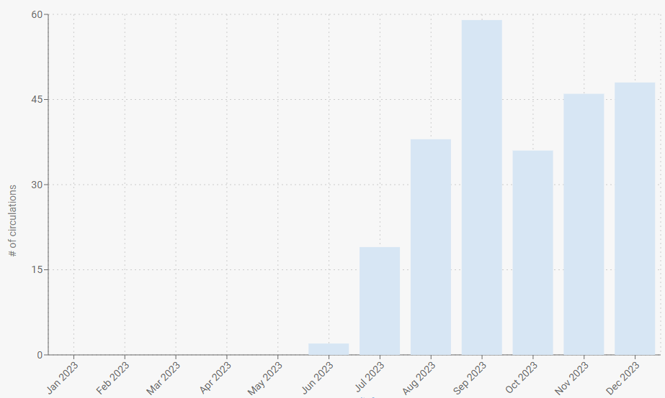

9

December circulation statistics:

